Experimental study on convective heat transfer of TiO₂ nanofluids
M. Vakili, A. Mohebbi∗ and H. Hashemipour
Department of Chemical Engineering, College of Engineering, Shahid Bahonar University of Kerman, Kerman, Iran, P.O. Box 76175-133.

Abstract
In this study, nanofluids with different TiO₂ nanoparticle concentrations were synthesized using the two-step method and measured for their heat transfer behavior upon flowing upward through a vertical pipe in laminar and turbulent flow regimes. The measurements were performed in different constant heat fluxes. For the comparison of heat transfer improvement in fluids with different thermal conductivity, in addition to distilled water as base fluid, the mixture of distilled water/ethylene glycol was used too. Addition of nanoparticles into the base fluid enhances the forced convective heat transfer coefficient and the enhancement increases with increasing particle concentration. The effect of particle concentration seems to be more in higher flow Reynolds number and higher heat fluxes. The results also show that the enhancement of the convective heat transfer coefficient in the mixture consisting of ethylene glycol and distilled water is more than distilled water as the base fluid. Maximum enhancement in heat transfer coefficient occurs in turbulent flow regime of nanofluids with high concentration of nanoparticles and low thermal conductivity.

Keywords: Nanofluids; Forced convection; Base fluid; Heat flux; TiO₂ nanoparticles
Introduction
Working fluids such as water and ethylene glycol are essential for heat transfer in many industrial sectors [1]. The ability of a working fluid medium to transfer a large quantity of heat across a small temperature difference enhances the efficiency of energy conversion and improves the design and performance of advanced heat transfer systems [2].
In recent years, the new class of heat transfer fluids- nanofluids which are engineered by dispersing small quantity (<5 vol. %) various types of nanoparticles into conventional working fluids, demonstrate a significant increase in their heat transfer properties [3]. In addition it can solve the problems such as sedimentation, cohesion and corrosion, which happen conventionally in heterogeneous solid/liquid mixture with millimeter or micrometer particles [4,5]. Compared with the existing techniques for enhancing heat transfer, the nanofluids show a great potential in increasing heat transfer rates in a variety of application cases. Thermal conductivities orders of magnitudes higher than base fluid, heat transfer system size reduction, microchannel cooling and miniaturization of systems and excellent stability are various benefits of the application of nanofluids. There are only small numbers of studies (< 18%) involved in describing fluid flow and convective heat transfer performance of nanofluids since the invention approximately up a decade ago.
Masuda et al. [6] reported that suspension of 3.25-4.30 vol. % 27, nm titanium dioxide particles in water shows 0.5-10% increase in thermal conductivity. They also reported thermal conductivity increases with increasing concentration of particles and temperature.
Pak and Cho [7] performed viscosity, pressure loss and heat transfer measurements on 27 nm titanium dioxide nanofluids up to 3 vol. % (pH = 10) and found single-phase correlations can be successfully extended to nanofluids. They proposed a new correlation for the turbulent convective heat transfer for dilute concentration of nanofluids as follows:
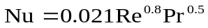 for (1)
Murshed et al. [8] studied thermal conductivity of 15 nm sphere and 10×40 nm rod titanium dioxide/water nanofluids and showed that the suspended nanoparticles ( 0.50-5.00 vol. %) enhance 5-30% thermal conductivity of base fluid.
Wen and Ding [9] found the addition of 0.19 vol. % of 34 nm titanium dioxide nanoparticles decreases single phase heat transfer of natural convection in short vertical cylinder by 2-15%. Also, 0.35 vol. % and 0.57 vol. % titanium dioxide lead to 5-36% decrease in the same conditions. They found that 34 nm titanium dioxide/water nanofluids (pH = 3) up to 0.68 vol. % enhance 0.2-6% thermal conductivity of base fluid.
He et al. [10] formulated stable aqueous 20 nm titanium dioxide with different agglomerate sizes and concentration. They measured static thermal conductivity and rheological behavior of nanofluids and studied heat transfer and flow behavior upon flowing upward through a vertical pipe in both the laminar and turbulent flow regimes. They found convective heat transfer coefficient increases with nanoparticle concentration in both the laminar and turbulent flow regimes and concluded the effect of particle concentration can be more considerable in the turbulent flow regime. He et al. [11] compared the experimental data in the foregoing study with numerical results and a reasonable good agreement was achieved.
Sheikhzade et al. [12] studied the buoyancy-driven fluid flow and heat transfer in a differentially-heated rectangular cavity filled with the TiO₂-water nanofluid numerically. It is observed from the results that by increasing the volume fraction of the nanoparticles, the mean Nusselt number of the hot wall increases for the shallow cavities.
This work is aims on the forced convective heat transfer of nanofluids, made of TiO₂ nanoparticles and water or (ethylen glycol/water mixture). Stable titanium dioxide nanofluids are formulated and characterized followed by experiments on the heat transfer behavior of the nanofluids flowing upwards in a straight pipe under laminar and turbulence conditions. The objective of this study is to compare nanofluid convective heat transfer of water and ethylene glycol/water mixture as base fluid. Aqueous based nanofluids containing TiO2 nanoparticles of various concentrations will be tested under the different heat flux boundary conditions.

Experiments
Materials and nanofluids formulation
Dry titanium dioxide nanoparticles and distilled water were used to prepare nanofluids. The spherical nanoparticles were purchased from Degussa (Germany) with an average diameter of 25 nm. Ultrasonication was used for preparation of mixed aqueous suspensions, which is an accepted technique for dispersing nanoparticle in base fluid. Nanofluids containing 0.5%, 1.0%, 1.5% titanium dioxide by volume were produced by using the two step method, [10]. The titanium dioxide nanoparticles and a base fluid (distilled water or ethylene glycol/water mixture) were directly transferred into an ultrasonic vibrator (Tecna 6) and sonicated for 4 hours at a frequency of 50-60 kHz and an output power of 138W at 65ºC. No stabilizer was used in this work. No sedimentation was observed in produced nanofluids suspension after 24 hours. The pH value of the suspension was adjusted to 11 by NaOH solution to prevent re-agglomeration of the samples.

Measurements of the convective heat transfer coefficient
The experimental apparatus with constant heat flux boundary condition is shown schematically in Fig. 1. The test section was a vertically oriented straight copper tube with length of 120 cm, inner diameter of 6 mm and outer diameter of 8 mm. The tube was heated by two rod of heaters in parallel with tube. Different AC power supply was obtained by using a dimmer. There was a thick thermal isolating layer surrounding the heater to obtain a constant heat flux condition along the test section.
To measure the wall temperature at the outer surface of copper tube, four (K- type) thermocouples were welded on inner tube wall at the normalized axial positions of 20 cm (T_{w1}), 50 cm (T_{w2}), 80 cm (T_{w3}) and 110 cm (T_{w4}) from the inlet of the test section. Two further K-type thermocouples were inserted into the flow to measure fluid bulk temperature in tube at the normalized axial positions of 8 cm (T_{fin}) and 119 cm (T_{fout}). The thermocouples were calibrated in a thermostat water bath.
A glass vessel was used as fluid reservoir. After injection of nanofluid with specified concentration in reservoir tank, it was circulated toward the test section using a pump (STAR RS 25/6-130). Flow rate was measured by a flowmeter and different flow rate (0.5- 5.0 L/min) was obtained by using a valve before the flowmeter.
After passing the nanofluids through the test section, a tube-in-shell type heat exchanger was used to cool them where laboratory cooling water was used as the coolant. The steady state conditions were obtained after 45 minutes.

Problem formulation
The experimental data was used for calculation of the convective heat transfer coefficient (h) and Nusselt number as follows:
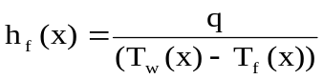 (2)
q is the heat flux, T_{w} is the measured wall temperature, and T_{f} is the fluid temperature calculated by the following energy balance equation:
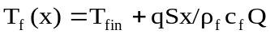 (3)
where T_{fin} is the measured fluid temperature at inlet of the test section, c_{f} is the fluid heat capacity, ρ_{f} is the fluid density, S is perimeter of the test tube and Q is the flow rate. For nanofluid, the value of (ρc) was calculated by the following equation:
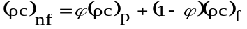 (4)
The measured temperature of fluid at the outlet of the test section was compared with the theoretical value calculated by Eq. (3), it was found that the maximum deviation was lower than 12% under the conditions of this work.
The convective heat transfer coefficient, h, in Eq. (2) is usually expressed in the form of the Nusselt number (Nu) as:
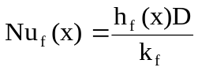 (5)
where D is the tube inner diameter and k_{f} is the fluid thermal conductivity and for nanofluid is predicted by the H-C model, [13]:
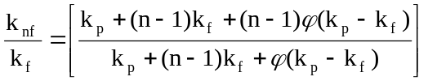 (6)
where n is the shape factor given by n = 3/ψ with ψ the sphericity (ψ = 1 for spherical particles). k_{f} and k_{p} are the thermal conductivities of the base fluid and particles, respectively. Traditionally, the Nu number is related to the Reynolds number defined as Re = ρ_{f}uD/μ_{f} and the Prandtl number defined as Pr = υ/α, where υ is the fluid kinematic viscosity, α is the fluid thermal diffusivity and μ_{f} is the fluid dynamic viscosity and for nanofluid is predicted by the Einstein equation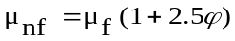. In Eq. (5) x represents axial distance from the entrance of the test section.

Results and discussion
Convective heat transfer coefficient of distilled water
The experimental system was tested with distilled water at two Reynolds number of 2960 and 3960. To check the constant heat flux boundary condition in this work, the experimental data of convective heat transfer coefficient of distilled water in form of Nu number was compared with predicted Nu number from Gnielinski equation, [14], (See Figs. 2(a) and 2(b)). This equation under the constant heat flux boundary condition is as follows:
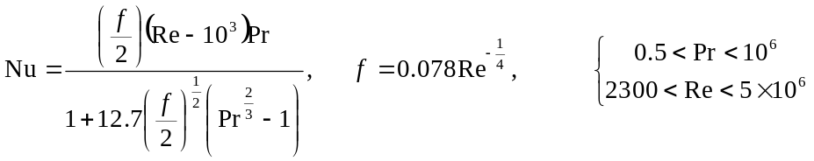 (7)
The Gnielinski equation predicts the experimental data by 4% deviation for Re = 2960 and 3% deviation for Re = 3960. These deviations are due to the effect of the entrance on heat transfer coefficient, which does not include in Eq. (7). Therefore, the boundary condition of constant heat flux for this study is valid.

Effect of nanoparticle concentrations on the convective heat transfer coefficient in distilled water
In Figs. 3(a) and 3(b), the axial profiles of the heat transfer coefficient of nanofluids increase with increasing particle concentration. The enhancement in the high Reynolds number is more than the low Reynolds number, namely, for example, at Re = 2960 and Re = 3960, the maximum enhancement with 1.50 vol. % TiO₂ nanofluids is about 40% (see Fig. 3(a)) and more than 52% (see Fig. 3(b)), respectivly.

Convective heat transfer coefficient of water/ethylene glycol mixture
The experimental system was tested with mixture consisting of 60 weight-% ethylene glycol and 40 weight-% distilled water at Re = 2030. Fig. 4 shows the measured data. This figure also compares the measured data with calculated values from Shah equation, [15]. Shah equation for the laminar flows under the constant heat flux boundary condition is as follows:
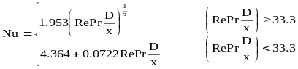 (8)
The Shah equation predicts the experimental data by 1.5% deviation for Re = 2030.

Effect of nanoparticle concentration on the convective heat transfer coefficient in mixture of water and ethylene glycol
Fig. 5 shows the axial profiles of the convective heat transfer coefficient of nanofluids with different TiO₂ particle concentrations in the mixture consisting of 60 weight-% ethylene glycol and 40 weight-% distilled water at Re = 2030. This figure indicates that with increasing particle concentration the convective heat transfer coefficient of TiO₂ increases.

Effect of heat flux on the convective heat transfer coefficient of nanofluid
Fig. 6 shows enhancement of convective heat transfer coefficient for power supply of 440W and 550W. In this figure the convective heat transfer coefficient in distilled water nanofluid increases with increasing heat flux. Results also show that the improvement of convective heat transfer coefficient of base fluid because of addition of nanoparticles seems to be more considerable in the turbulent flow regimes and higher heat fluxes.

Conclusions
In this study, an experimental work has been carried out on the heat transfer behavior of TiO₂ nanofluids flowing through a straight vertical pipe under both the laminar and turbulent flow conditions. The effect of nanoparticle concentrations, flow Reynolds number, type of base fluid and heat flux are investigated. The following conclusions are drawn from the results of experiments in this study:
- Addition of nanoparticles into the base fluid enhances the convective heat transfer coefficient and the enhancement increases with increasing particle concentration.
- The enhancement due to addition of nanoparticles seems to be more considerable in the high Reynolds number.
- Enhancement of the convective heat transfer coefficient for the mixture consisting of 60 weight-% ethylene glycol and 40 weight-% distilled water is more than the nanofluid of distilled water.
- The use of TiO₂ nanoparticles as the dispersed phase in distilled water can significantly enhance the convective heat transfer and the enhancement increases with increasing heat flux.

Nomenclature
c Heat capacity (kJ.kg⁻¹. ºC⁻¹)
D Inner diameter (m)
h Convective heat transfer coefficient (w.m⁻².ºC⁻¹)
k Thermal conductivity (w.m⁻¹. ºC⁻¹)
n Shape factor -
q Heat flux (w.m⁻²)
Q Flow rate (m³.s⁻¹)
S Perimeter of the tube (m)
T Temperature (ºC)
u Fluid velocity (m.s⁻¹)
x Axial position (m)

Greek symbols
α Thermal diffusivity (m².s⁻¹)
ρ Density (kg.m⁻³)
μ Viscosity (kg.m⁻¹.s⁻¹)
υ Fluid kinematic viscosity (m².s⁻¹)
φ Particle volume fraction -
ψ Sphericity -

Subcripts and Supercripts
f Fluid
w Wall of the test section
in Inlet of the test section
nf Nanofluid
p solid phase

References
[1] Wen, D. and Ding, Y., Experimental investigation into convective heat transfer of nanofluids at the entrance region under laminar flow conditions, Int. J. Heat Mass Tran., vol. 47, PP. 5181–5188, 2004.
[2] Chopkar, M., Dasb, P. K. and Mannaa, I., Synthesis and characterization of nanofluid for advanced heat transfer applications, Scripta Mater., vol. 55, PP. 549–552, 2006.
[3] Pfautsch, E., Forced Convection in Nanofluids Over a Flat Plate, Ph.D. thesis. Universidad de Tzou, D.Y., Missouri, 2008.
[4] Choi, C., Yoo, H.S. and Oh, J.M., Preparation and heat transfer properties of nanoparticle-in-transformer oil dispersions as advanced energy-efficient coolants, Curr. Appl. Phys., vol. 8, PP. 710–712, 2008.
[5] Yang, Y., Zhang, Z. G., Grulke, E. A., Anderson, W. B. and Wu, G., Heat transfer properties of nanoparticle-in-fluid dispersions (nanofluids) in laminar flow, Int. J. Heat Mass Tran., vol. 48, PP. 1107–1116, 2005.
[6] Masuda, H., Ebata, A., Termae, K. and Hishinuma, N., Altration of thermal conductivity and viscosity of liquid by dispersing ultra- fine particles (dispersion of γ-Al₂O₃, SiO₂ and TiO₂ ultra- fine particles, Netsu Bussei., vol. 7, PP. 227-223, 1993.
[7] Pak, B.C. and Cho, Y.I., Hydrodynamic and heat transfer study of dispersed fluids with submicron metallic oxide particle, Exp. Heat Transfer, vol. 11, PP. 151–170, 1998.
[8] Murshed, S. M. S., Leong, K. C. and Yang, C., Enhanced thermal conductivity of TiO2- water based nanofluids, Int. J. Therm. Sci., vol. 44, PP. 367-373, 2005.
[9] Wen, D. and Ding, Y., Natural convective heat transfer of suspensions of titanium dioxide nanoparticles (nanofluids), IEEE T. Nanotechnol., vol. 5, PP. 220-227, 2006.
[10] He, Y., Jin, Y., Chen, H., Ding, Y., Cang, D. and Lu, H., Heat transfer and flow behaviour of aqueous suspensions of TiO₂ nanoparticles (nanofluids) flowing upward through a vertical pipe, Int. J. Heat Mass Tran., vol. 50, PP. 2272–2281, 2007.
[11] He, Y., Men, Y., Zhao, Y., Lu, H. and Ding, Y., Numerical investigation into the convective heat transfer of TiO₂ nanofluids flowing through a straight tube under the laminar flow conditions, Appl. Therm. Eng., vol. 29, PP. 1965-1972, 2009.
[12] Sheikhzade, A., Arefmanesh,A., Mahmoodi, M., Numerical study of natural convection in a differentially-heated rectangular cavity filled with TiO₂-water nanofluid. J. nano research, vol. 13, PP. 75-80, 2011.
[13] Hamilton, R.L. and Crosser, O.K., Thermal conductivity of heterogeneous two-component systems, I&EC Fundam., vol. 125 (3), PP. 187–191, 1962.
[14] Gnielinski, V., New equations for heat and mass transfer in turbulent pipe and channel flow, Int. Chem. Eng., vol. 16, PP. 359-368, 1976.
[15] Shah R. K, Thermal entry length solutions for the circular tube and parallel plates, Proc. 3th Intl. Heat Mass Trans. Conf., vol. ,PP. 11-75, 1975.

Figure captions
Fig. 1. Experimental Apparatus
Fig. 2. Comparison of the measurements with the Gnielinski equation for distilled water flows. (a) Re = 2960 and (b) Re = 3960.
Fig. 3. Axial profiles of heat transfer coefficient of nanofluids at different TiO₂ nanoparticle concentrations in the turbulent flow regimes of water. (a) Re = 2960 and (b) Re = 3960.
Fig. 4. Comparison of the measurements with the Shah equation for mixture of water and ethylene glycol flows at Re = 2030.
Fig. 5. Axial profiles of heat transfer coefficient of nanofluids at different TiO₂ nanoparticle concentrations in the mixture consisting of 60 weight-% ethylene glycol and 40 weight-% distilled water.
Fig.6. Effect of heat flux on the convective heat transfer coefficient of nanofluid in different TiO₂ nanoparticle concentrations

Figure 1:

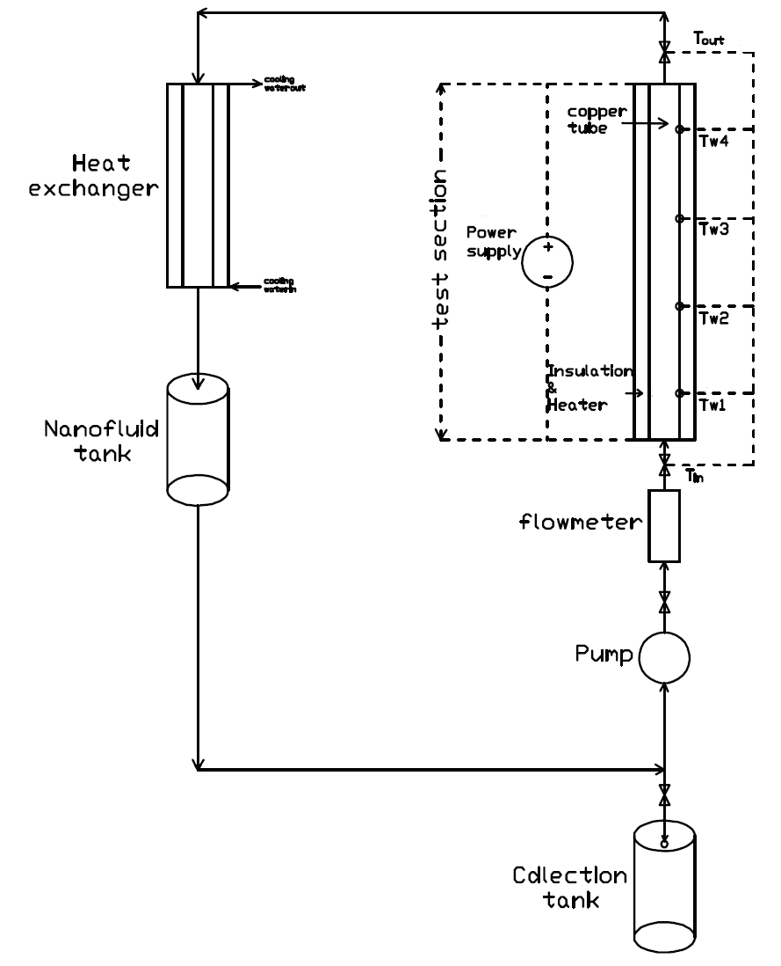

Figure 2:
(a)
0
10
20
30
40
0
20
40
60
80
100
120
140
160
180
200
X/D
Nu
Experimental data
Gnielinski Equation[39]
(b)
10
20
30
40
50
0
20
40
60
80
100
120
140
160
180
200
X/D
Nu
Experimental data

Gnielinski Equation[39]

Figure 3:
h(x)(W/m²K)
(a)
0
2000
4000
0
20
40
60
80
100
120
140
160
180
200
X/D
h(x)(W/m²K)
water
nanofluid 0.5 Vol. % TiO₂
nanofluid 1.0 Vol.% TiO₂
nanofluid 1.5 Vol. % TiO₂
(b)
0
2000
4000
6000
0
20
40
60
80
100
120
140
160
180
200
X/D
water
nanofluid 0.5 Vol. % TiO₂
nanofluid 1.5 Vol. % TiO₂
nanofluid 1.0 Vol.% TiO₂

Figure 4:
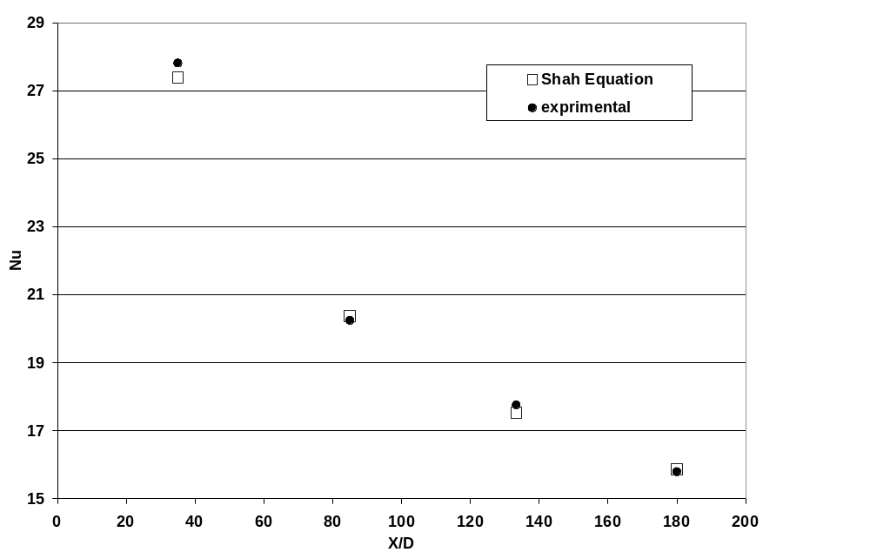
Figure 5:
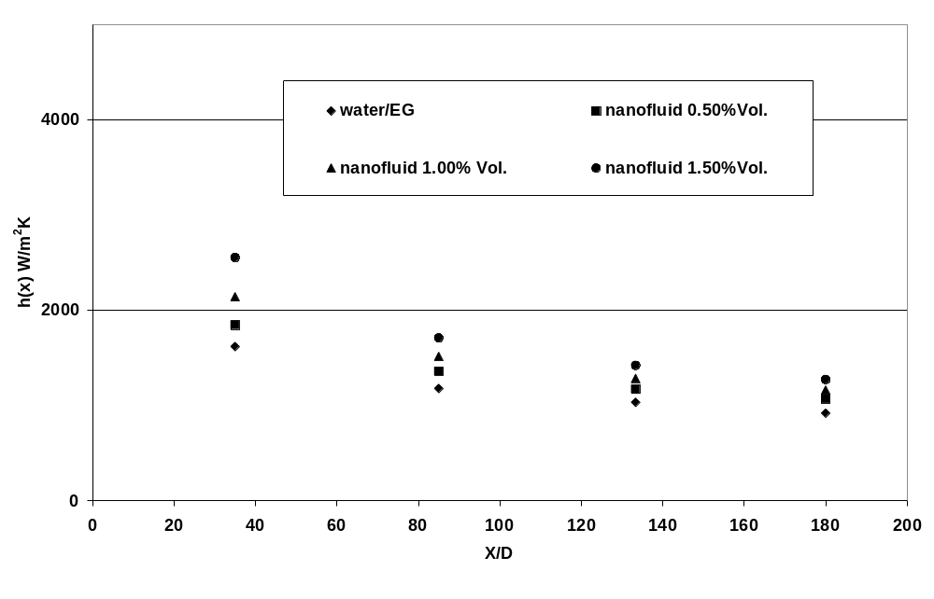

Figure 6:
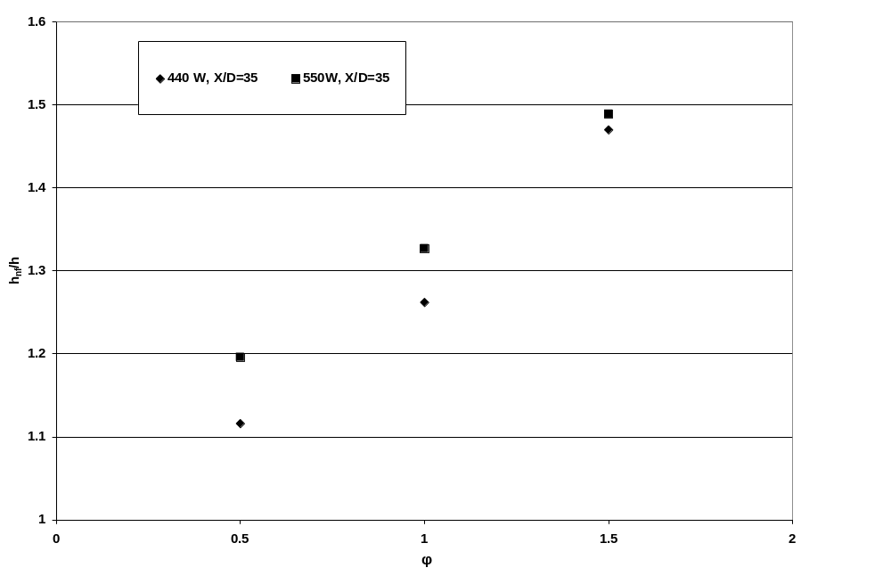

 Corresponding author. Tel & Fax +983412118298 E-mail: amohebbi2002@yahoo.com amohebbi@mail.uk.ac.ir

